

Project Interim Report

On

Online Quiz Application

(Using Core Java & OOP Concepts)
RU-100-01-00012
Object Oriented Programming with Java

SESSION: 2025-26

Submitted By Riddhi Deshmukh
Reg no. - 11161

Bachelor of Technology in Computer Science &
Engineering in association with Google

Under the Guidance of
Mr. Ashish Shivhare

SCHOOL OF COMPUTER SCIENCE AND ENGINEERING RUNGTA INTERNATIONAL SKILLS UNIVERSITY
BHILAI, CG

(April 2026)

Certificate

Acknowledgement

Abstract

An online quiz application developed using Object-Oriented Programming (OOP) is a system that allows users to participate in quizzes digitally in a simple and interactive way. Instead of writing everything in one block of code, OOP helps organize the program into smaller parts called classes, such as users, questions, quizzes, and results. This makes the application easier to understand, manage, and update in the future. The system can include features like user login, timed questions, automatic checking of answers, and instant result display. By using OOP concepts like encapsulation and inheritance, the program becomes more secure and flexible. Overall, this approach helps in building a well-structured, efficient, and user-friendly quiz platform for learning and assessment.

Introduction

The Online Quiz Application is a software project developed using Object-Oriented Programming (OOP) concepts to create an efficient and interactive platform for conducting quizzes digitally. The main idea behind this project is to replace traditional paper-based tests with a system that is faster, more organized, and user-friendly. The application allows users to register, log in, attempt quizzes, and receive instant results. It can include multiple categories of quizzes, time limits, and automatic evaluation of answers, which makes the overall process smooth and efficient.

By using OOP principles such as encapsulation, inheritance, polymorphism, and abstraction, the project is divided into different classes like User, Question, Quiz, and Result. This makes the system easy to maintain, reusable, and scalable for future improvements like adding leaderboards or advanced analytics. The application not only saves time but also reduces human errors and manual effort in checking and managing quizzes.

Objectives

Manage quiz questions and user data efficiently

Track user performance and scores

Reduce manual work in conducting and evaluating quizzes

Provide instant and accurate results

Apply Object-Oriented Programming concepts for better design and structure

Scope

The Online Quiz Application enables efficient quiz management, automatic evaluation, and performance tracking while reducing manual effort.
It can be used in education and training, with scope for future expansion into web or mobile platforms with advanced features.

System Requirements

Hardware Requirements

Processor: Intel Core i3 or above

RAM: Minimum 4 GB

Storage: At least 500 MB free space

Display: Standard monitor (1366×768 resolution or higher)

Input Devices: Keyboard and mouse

Software Requirements

Operating System: Windows / Linux / macOS

Programming Language: Java / Python / C++ (any OOP-based language)

IDE: Eclipse / IntelliJ IDEA / VS Code

Database (optional): MySQL / SQLite

Browser (for web version): Google Chrome / Edge / Firefox

Methodology
Explain how your project works like first we add something, then search, then modify etc.

Flowchart

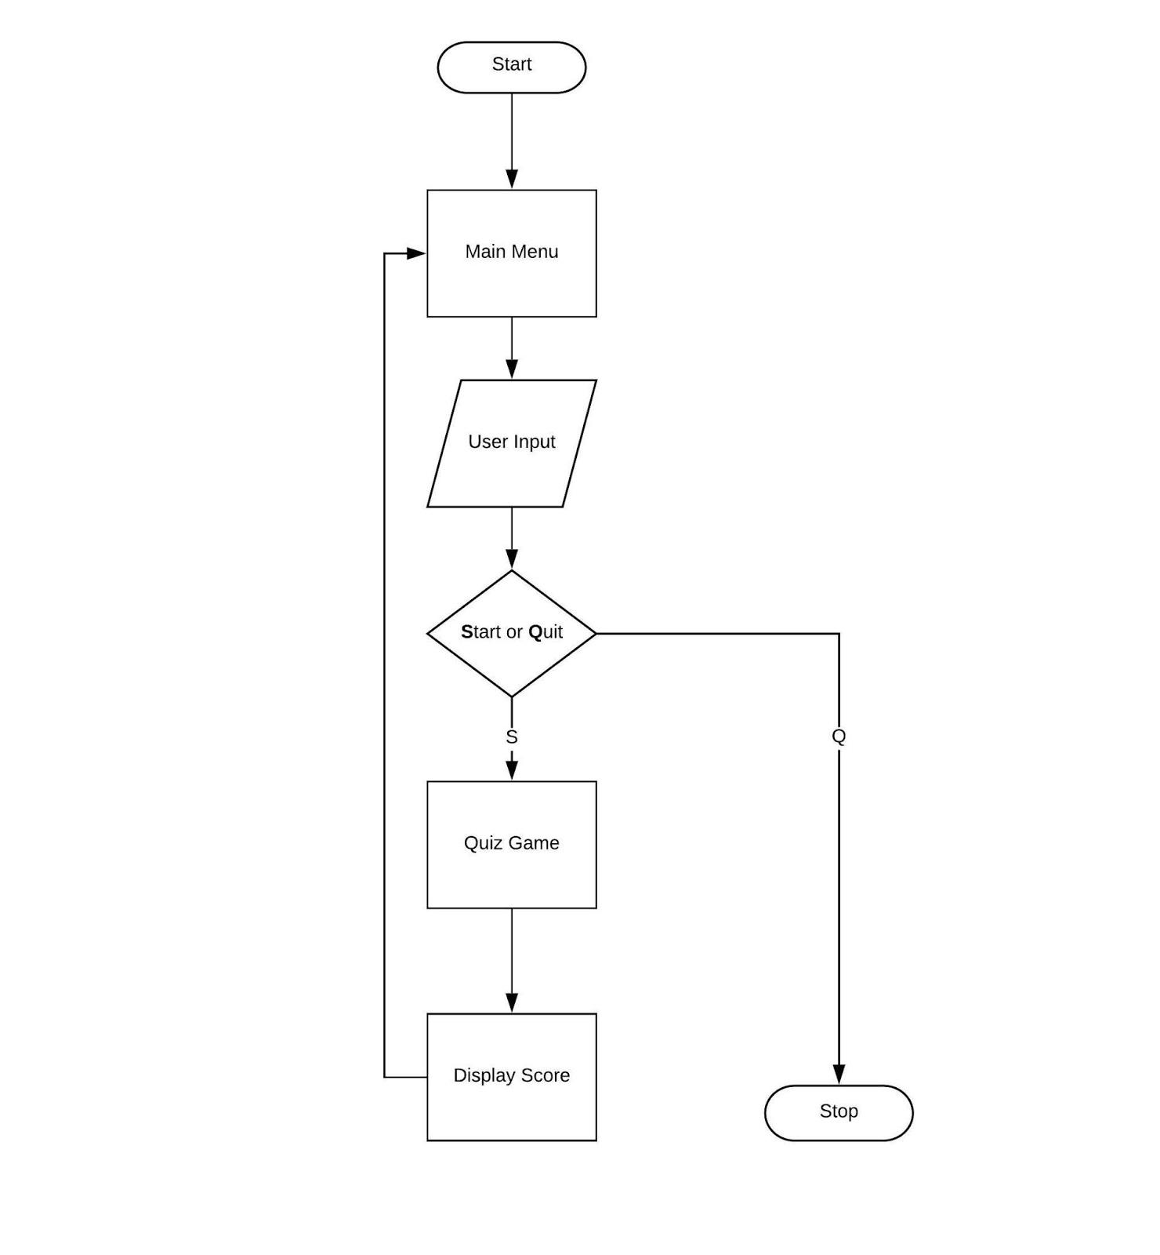

ClassName
- User – Stores user details and handles login or identification before starting the quiz.
- Quiz – Manages the overall quiz flow like starting the quiz, showing questions, and controlling the sequence.
- Question – Contains the question, options, and correct answer, and checks whether the user’s response is correct.
- Result – Calculates the final score and displays the performance of the user at the end of the quiz

Implementation

The program uses four main classes: User for login, Quiz to control quiz flow, Question to store and check answers, and Result to calculate and display scores. Each class handles a specific task, making the system simple and organized.

Sample Input / Output

Input: User selects quiz and answers questions
Output: System displays total correct answers and final score

Future Enhancements (Short)

Add GUI, database support, timer, leaderboard, and convert into web/mobile application.

Gantt Chart
- Planning & Structure
For the Online Quiz Application, the Gantt chart helps divide the project into clear stages like designing classes (User, Quiz, Question, Result), coding the logic, testing the quiz system, and final documentation. Even if the project is small, proper planning ensures each part is developed step-by-step without confusion.

Time Management
It shows when each stage of your quiz project starts and ends, such as when coding begins or when testing is completed. This helps you complete tasks on time, avoid last-minute work, and manage your project smoothly and efficiently

Conclusion
The Online Quiz Application provides an efficient and user-friendly way to conduct quizzes with automatic evaluation and result generation.
Using OOP concepts, the system is well-structured, easy to manage, and can be expanded with advanced features in the future.

References Book
[1] E. Balagurusamy, Object-Oriented Programming with C++, 8th ed. New Delhi: McGraw-Hill Education, 2019.
[2] E. Balagurusamy, Programming with Java, 6th ed. New Delhi: McGraw-Hill Education, 2019.

Website
[3] Oracle, "Java Documentation," Oracle. [Online]. Available: https://docs.oracle.com

Conference Paper
[4] A. Sharma, "Online Quiz System Using OOP," in Proc. Int. Conf. on Computer Science, 2022, pp. 45-50.

Journal Article
[5] R. S. Pressman, “Software Engineering: A Practitioner’s Approach to Object-Oriented Systems,” Journal of Software Engineering Applications, vol. 10, no. 3, pp. 120–130, 2017.
[6] S. K. Singh and P. Kumar, “Design and Implementation of Online Quiz System Using Java,” International Journal of Computer Applications, vol. 182, no. 25, pp. 15–19, 2019.

